(Git / GitHub)

- Install Git and configure username and email.
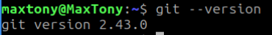
- Create a local repository, add a file, and commit changes.
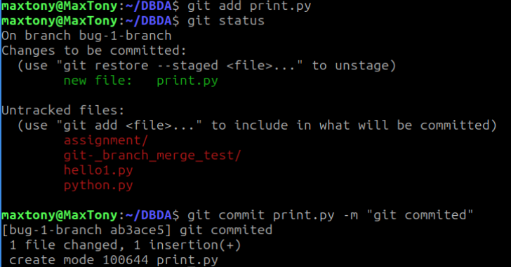

- Create a new branch, switch to it, make changes, and merge it with `main`.
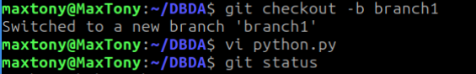

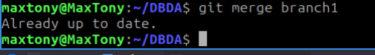

- Push the local repository to GitHub using command line.

- Clone a repository from GitHub, edit files, and push changes back.
